Jump to: Step-by-Step About this topic Tips Related Topics

# Step-by-Step

## Setup a New Panel

Panels provide a way to group a set of analytes across departments, instruments and controls according to the way you want to view and enter data within your Unity Next lab.

1. If applicable, click **Unity Next** in the top left corner to return to the Dashboard.
2. Click **Add a Panel** located on the left side of the screen.

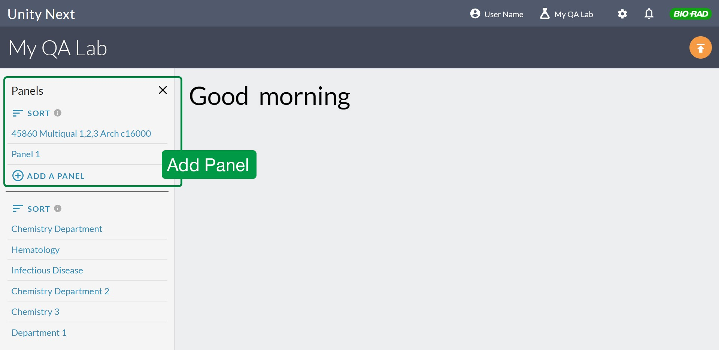

1. Type a name for your panel in the Panel name field.

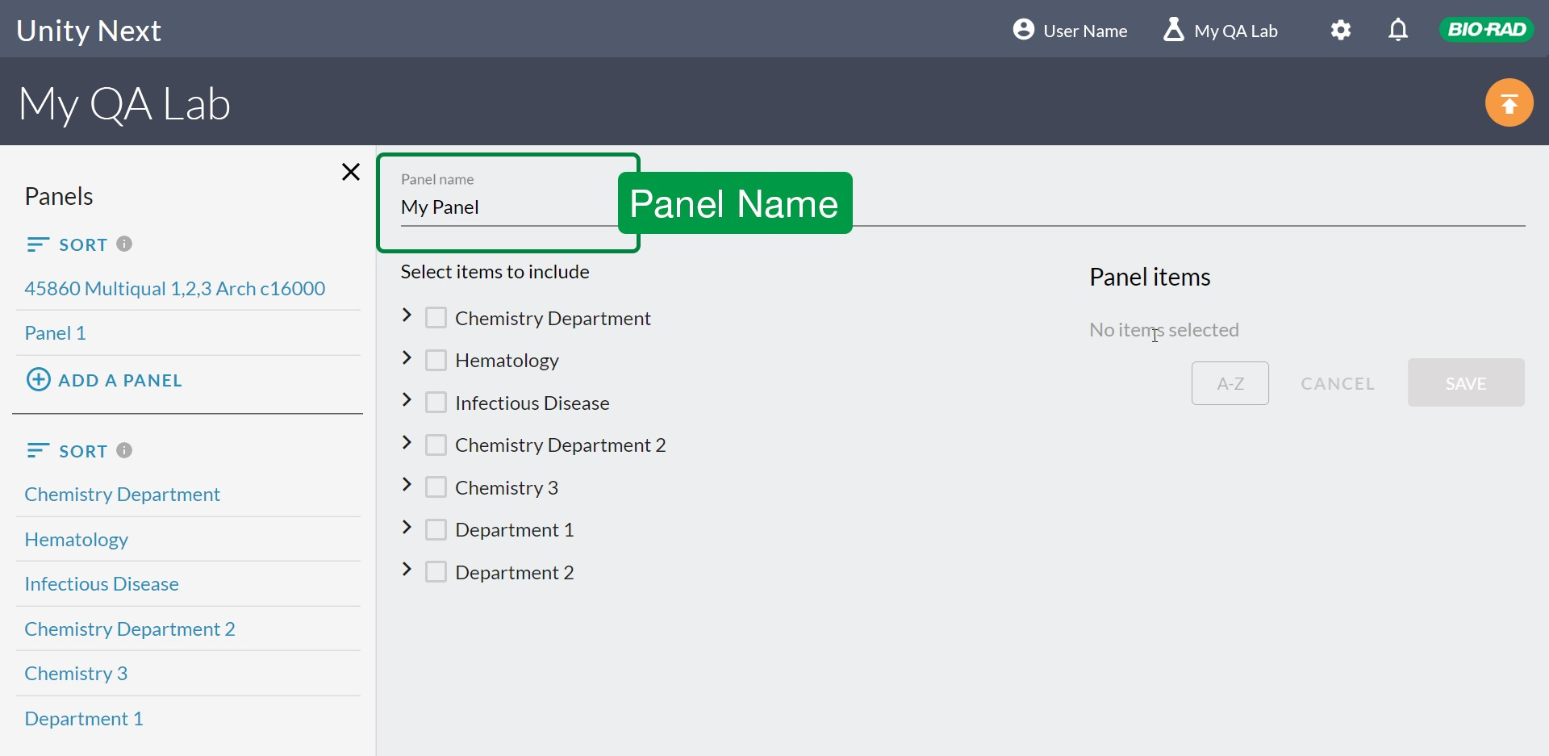

1. Select which items to include in your Panel by selecting the applicable boxes.

Click the > symbol to the left of the Department name to expand the list and view the controls. Click the > symbol to the left of the Control name to expand the list and view the analytes.

* The selected analytes will appear under Panel items on the right while you are adding a panel.
* To remove an analyte from the Panel, click the **X** next to the analyte name under Panel items or uncheck the applicable blue box in the list on the left side of the screen.

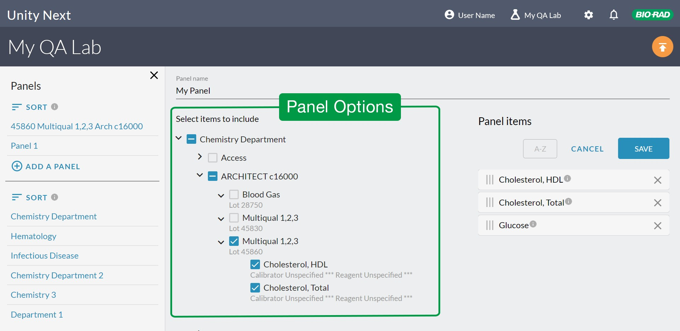

6. Click **Save**.

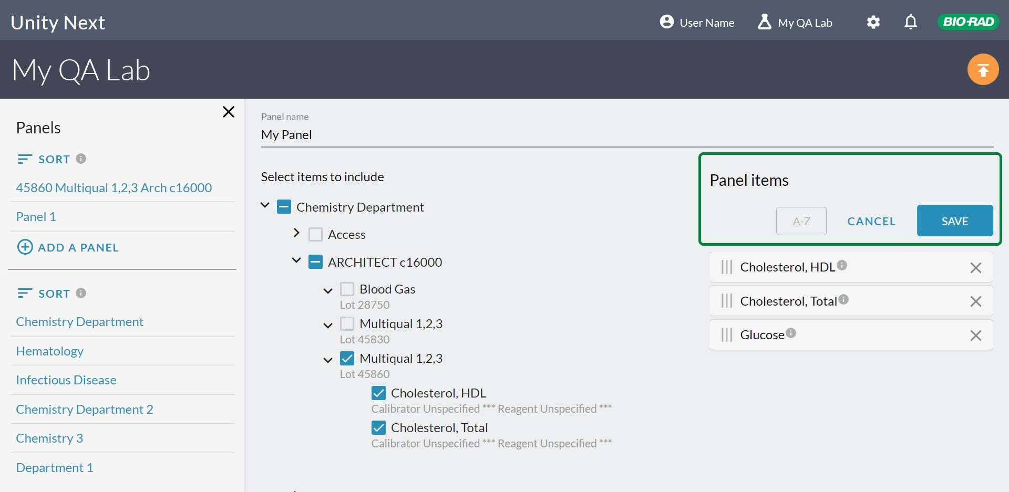

## Edit or Delete Panels

1. If applicable, click **Unity Next** in the top left corner to return to the Dashboard.
2. Click the panel name on the left side of the screen.

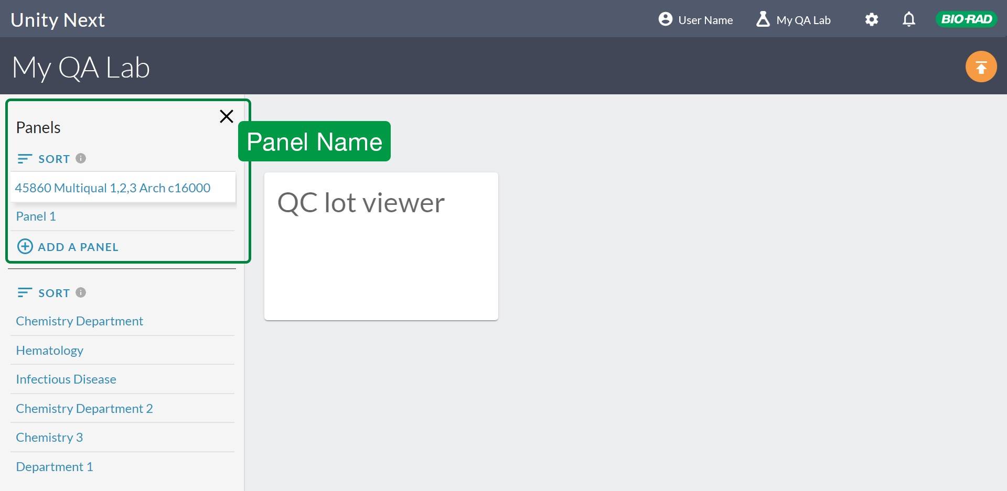

1. Click **Edit this Panel** at the top of the screen.

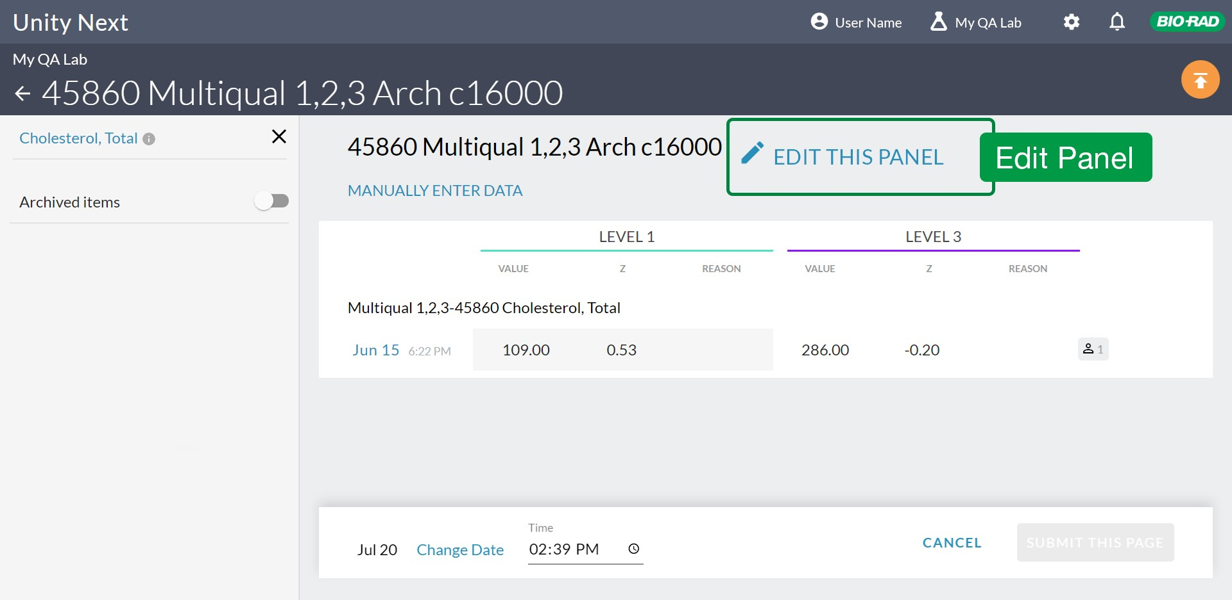

1. Click the red trash can to delete the panel.

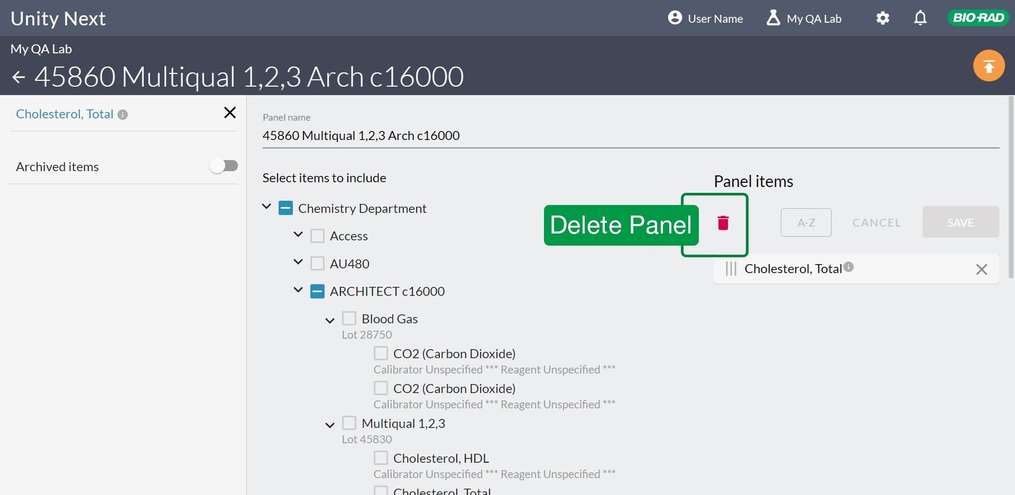

1. Select the items to include in your Panel by selecting the applicable boxes.

Click the > symbol to the left of the Department name to expand the list and view the controls. Click the > symbol to the left of the Control name to expand the list and view the analytes.

* The selected analytes will appear under Panel items on the right while you are editing a panel.

1. To remove an analyte from the Panel, click the **X** next to the analyte name under Panel items or uncheck the applicable blue box in the list on the left side of the screen.



1. Click **Save**.



# About setting up panels

Panels provide a way to group a set of analytes across departments, instruments and controls according to the way you want to view and enter data within your Unity Next lab.

For example, you can make data entry easier by using a panel to group together multiple instances of the same analyte, even if they are found across different departments, instruments or lot numbers within your lab. You can add a single test to multiple panels or sort multiple analytes within a single panel.

**Tips**

Panels can be edited or custom sorted, as needed, and you can choose to show or hide archived items in your panels.

**Related Topics** Add a Department [Add Analyte](https://biorad.sharepoint.com/hc/en-us/articles/360061606611)

Custom Sorting